**SRS Document For E-Commerce Website**

Functional Requirements:

1. User Management

- Register new users (user,seller, administrators).

- Authenticate users.

- Manage user profiles.

2. User Management

- Record user information (name, age, gender, address, mobile number etc.)

- Generate a data and time for the delivery

3. Seller Management

- Record Seller information (name, shop name , shop address , shop document ,etc.)

- Generate a data and time for the delivery

4. Appointment Management

- Allow patients to request appointments.

- Notify doctors of appointment requests.

- Confirm appointments.

5. Product Listing and Inventory Management

- Add New Products.

- Edit Product Information

- Inventory Tracking.

5. Shopping Cart and Checkout Process

5.1 Shopping Cart Management

Add to Cart: Users can add products to their shopping cart from the product detail pages.

View Cart: Users can view all items in their cart along with quantities, prices, and total cost.

Update Cart: Users have the option to update the quantity or remove items from their cart.

Save for Later: Users can save items in their cart for future purchase.

5.2 Checkout Process

Checkout Initiation: Users initiate the checkout process from their shopping cart.

Shipping Address: Users can enter a new shipping address or select an existing one.

Shipping Options: The system will present various shipping options, including costs and estimated delivery times.

Payment Information: Users enter their payment details or select saved payment methods.

Order Review: Before submission, users can review their order details, including items, shipping, and payment.

Order Confirmation: Upon submission, the system confirms the order and provides an order number.

6. Payment Gateway Integration

Payment Methods: The system supports multiple payment methods, including credit cards, debit cards, online banking, and mobile wallets.

Payment Processing: Integrate with trusted payment gateways for secure payment processing.

Transaction Security: Ensure all transactions are encrypted and comply with PCI DSS standards.

Payment Confirmation: Users receive confirmation of payment through the website and via email.

7. Order Management

7.1 Order Placement

Order Tracking: Users can track the status of their order through the website.

Order History: Users can view their past orders and details.

7.2 Seller Order Management

Order Notification: Sellers receive notifications of new orders.

Order Processing: Sellers can update order statuses as they process, pack, and ship items.

Order History: Sellers have access to the history of orders received and processed.

8. Shipping and Delivery Management

Shipping Partners Integration: The system integrates with shipping partners to automate shipping and tracking.

Shipping Notifications: Users receive notifications with tracking information once their order is shipped.

Delivery Time Estimation: The system provides estimated delivery times based on the shipping method and destination.

9. Customer Support Services

FAQ Section: A comprehensive FAQ section addresses common questions and issues.

Live Chat Support: Live chat allows customers to get immediate assistance.

Email Support: Customers can contact support via email for non-urgent inquiries.

Return and Refund Policy: Clearly outline the process for returning products and obtaining refunds.

10. Security Requirements

User Authentication and Authorization: Secure user authentication and role-based access control.

Data Encryption: Encrypt sensitive data, including personal information and payment details.

Security Audits: Regular security audits to identify and mitigate vulnerabilities.

Compliance: Ensure compliance with legal regulations regarding data protection, privacy, and electronic transactions.

11. Performance and Scalability

Load Handling: Ensure the system can handle high traffic and transaction volumes, especially during peak times.

Scalability: Design the system to be scalable, allowing for easy addition of new features and handling increased loads without degradation in performance.

Non-functional requirements (NFRs) specify the quality attributes of a software system. They define how the system performs a certain function, rather than the functionality itself. For an eCommerce website, non-functional requirements are critical as they directly impact user experience, system performance, security, and overall success. Here are key non-functional requirements you might consider for your SRS document:

1. Performance Requirements

Response Time: Web pages should load within 3 seconds under normal conditions to ensure a smooth user experience.

Throughput: The system must handle a minimum of 10,000 users simultaneously without performance degradation, with the ability to scale during peak shopping periods.

Bandwidth: Optimize the website to ensure minimal bandwidth consumption while maintaining high-quality visuals and functionality.

2. Scalability

System Scalability: The eCommerce platform must be designed to easily scale out to accommodate increasing numbers of users, transactions, and data.

Database Scalability: Databases should be optimized for high read and write operations and should scale horizontally as the user base grows.

3. Availability and Reliability

Availability: The eCommerce website should aim for 99.9% availability, minimizing downtime to less than 8 hours annually.

Reliability: The system should have a failure rate of less than 0.1%, with robust error handling and logging mechanisms for quick recovery and troubleshooting.

4. Security

Data Protection: All user data, including personal and payment information, must be encrypted both in transit and at rest.

Authentication and Authorization: Implement strong authentication mechanisms and role-based access controls to secure sensitive operations and data.

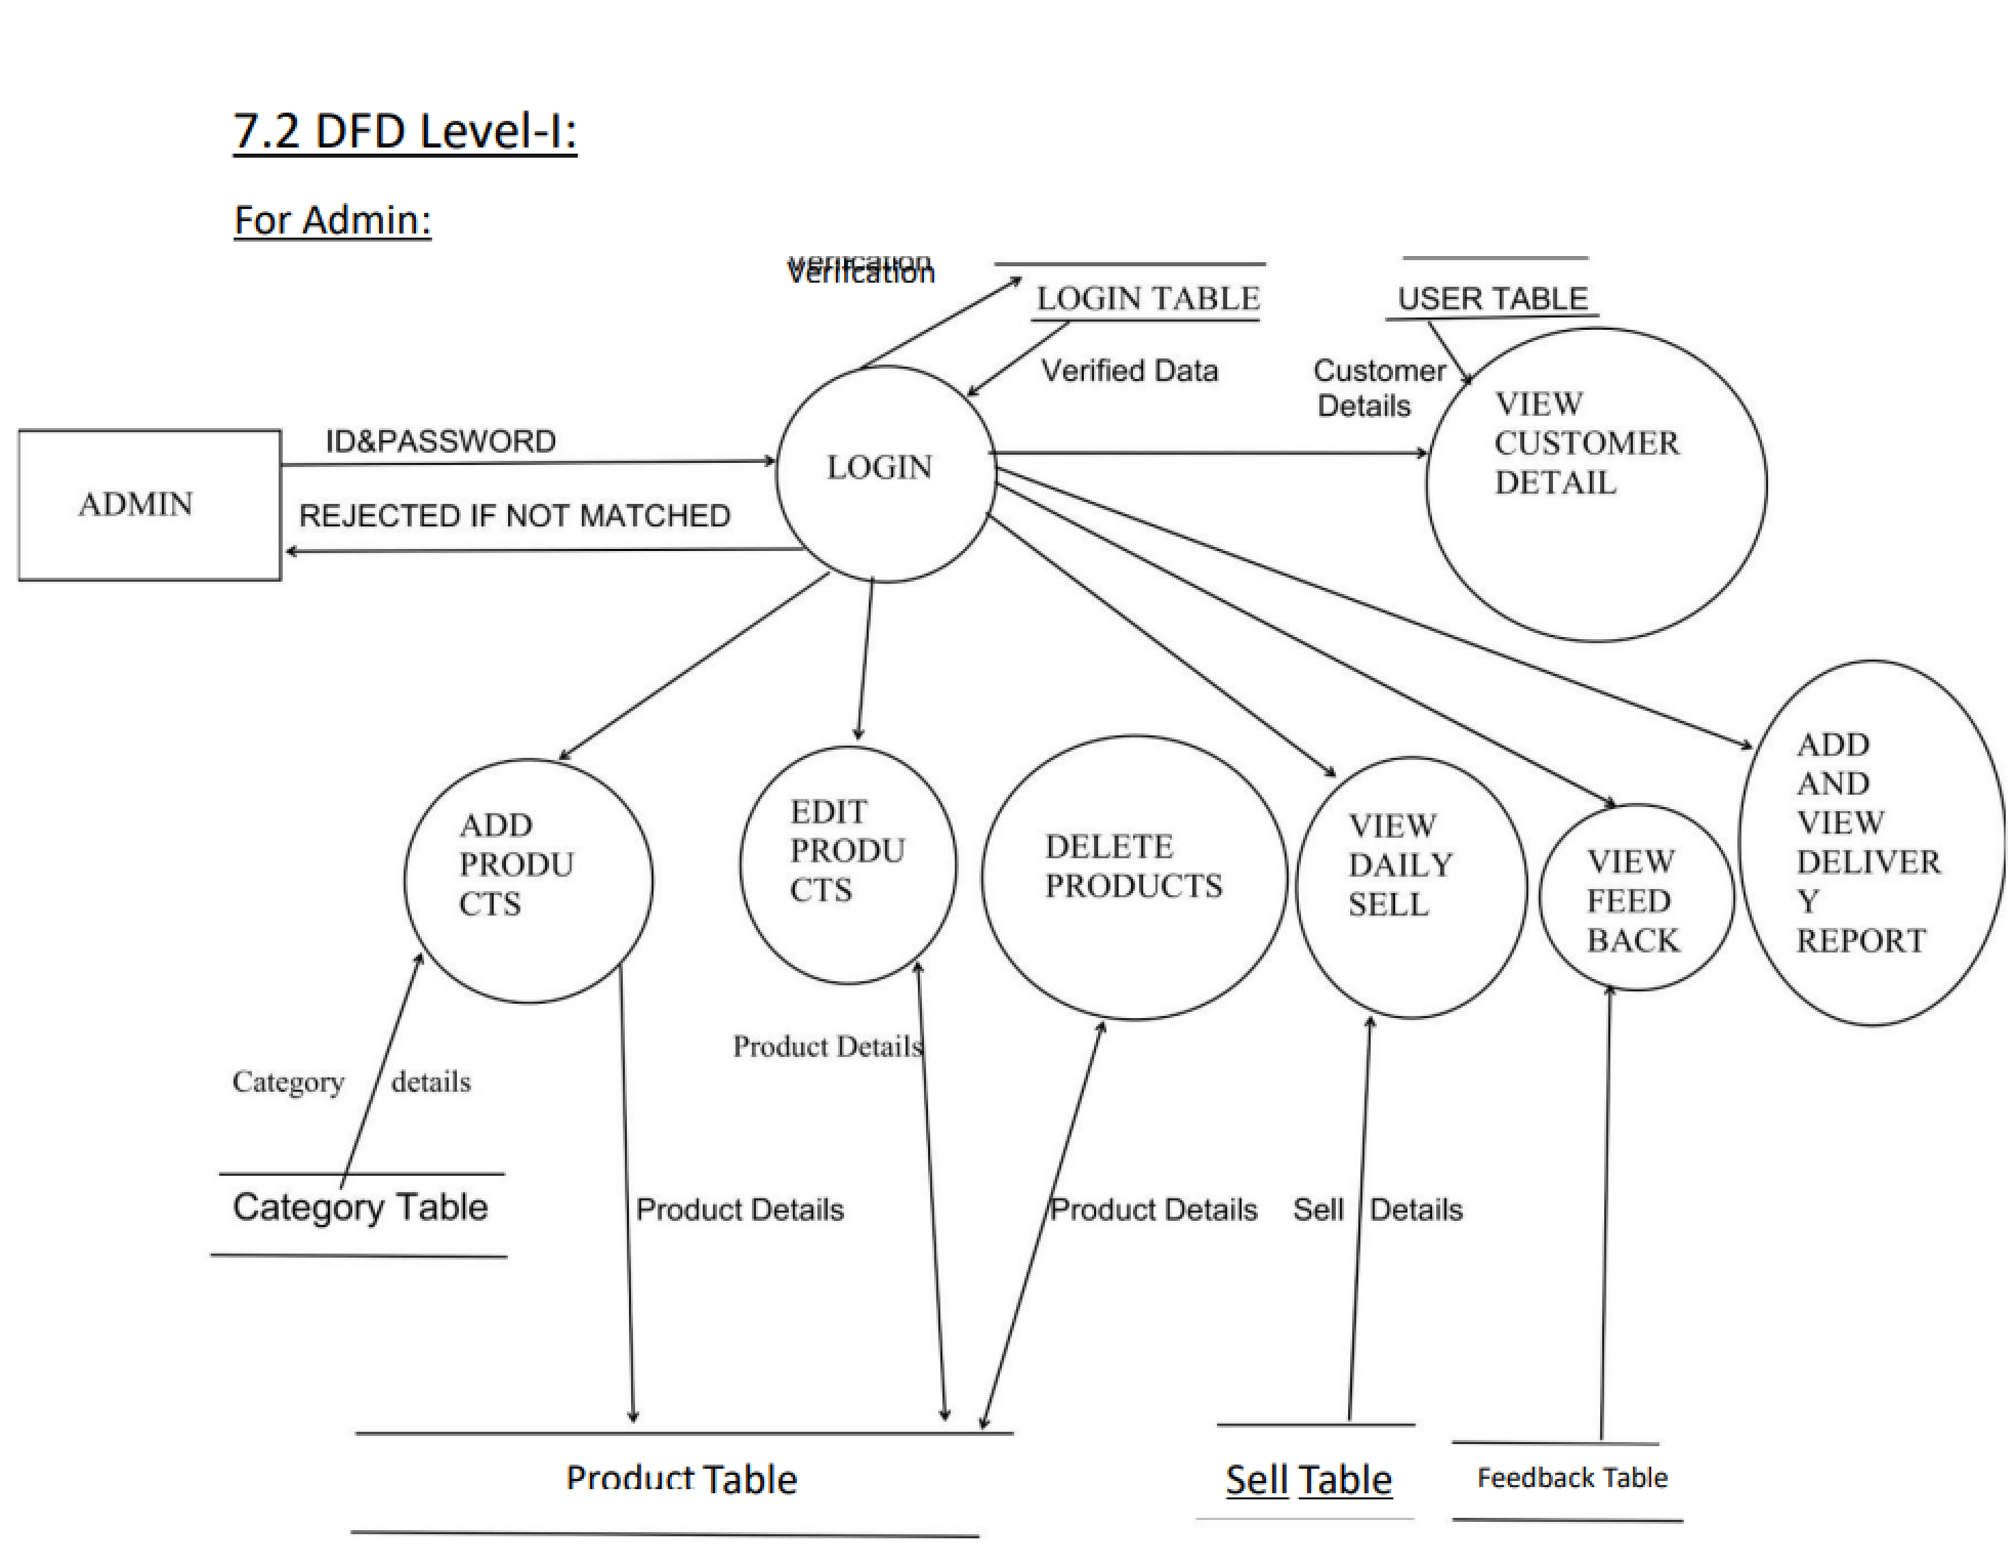Compliance: Ensure compliance with relevant legal and regulatory standards like GDPR for data protection and PCI DSS for payment processing.